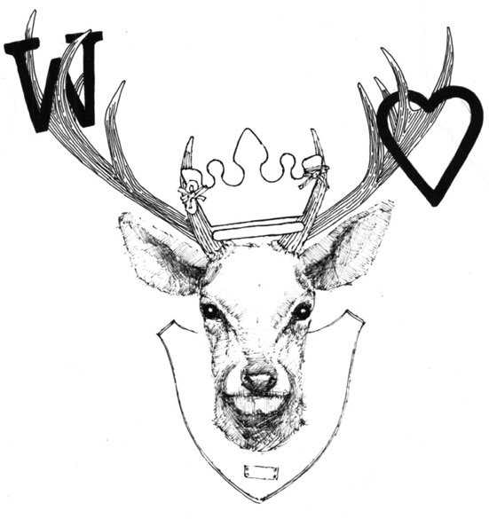

Nibbles
Chilli & garlic marinated olives £4.00
Selection of home pickled veg £5.00

Classics
Sussex x Waygu burger, cheese baconaise, fries, salad £15.75
Battered catch of the day, bacon peas, tartare hand cut chips £16.75
Buttermilk chicken burger, siracha mayo, purple slaw, fries £15.25

Meat
Sussex x Waygu bavette, fries, peppercorn £24.00
Meatballs, chorizo, tomato, sourdough £6.50
Beef carpaccio, peppercorns, parmesan £8.50
Pulled harissa lamb, baby onions, flatbread £8.50

Fish
Lemon sole, caper butter, new potatoes, salad £22.50
Squid salad, chilli jam £7.00
Mackerel pate, sourdough £7.00

Vegetarian
Beetroot & goats cheese salad, orange, honey £11.00
Watermelon salad crispy noodles, hoisin dressing £8.50
Babaganoush, flatbreads £5.00
Padron pepper, lemon mayo £5.00

Raw/Cured/Cheese
Cheese plate, chutney, crackers £8.50

Sharing
12 hour home smoked brisket, house salad, homemade flatbreads, chorizo mac n cheese, coleslaw £18.00/£30.00

Sides
Hand cut chips £5.00
Fries £4.00
Side salad £3.50
Coleslaw £3.00
Chorizo mac ‘n’ cheese £5.00
Mondays – Locals Night Two courses £16 + bring your own wine
Tuesdays – Two bavettes & a bottle of house wine £35

